|  |
| --- |
| Pixel IT Labs |
| PITCH |
| Testing Guide |
|  |
| **Grace Carrillo** |
| **9/25/2015** |

Contents

1 Administration 2

1.1 Environments 2

1.2 Login to Admin 3

2 High Priority Amendments 4

2.1 ID 1: Per-Location Traffic Manager Emails 4

2.2 ID 16, 34: Quick Book Process 8

2.3 ID 19: Booking Brief Update Error 13

2.4 ID 39: Website Automated Emails 17

2.5 ID 41: Content Update 18

2.6 ID 43: Enhancements 19

2.7 ID 40: On the Submission Form 19

3 Medium Priority Amendments 23

3.1 ID 4: Unique URLs Per Tab 23

3.2 ID 18: Remember and Utilize Tab Selection Per Session 25

3.3 ID 18: No Comms Process 27

3.4 ID 24: Change of Event/Workshop 30

3.5 ID 20: Booking Invite Formatting 32

3.6 ID 26: Manage Workshop Booking Date 33

3.7 ID 30: Trends Order 37

3.8 ID 33: Un-editable Proposal Template in the Backend 41

4 Low Priority Amendments 44

4.1 ID 29: 8MB Upload Limitation 44

# Administration

## Environments

* 1. **UAT**: This is the pre-production environment where all changes are made and testing is done

Website

[http://pitch1-uat.unileversolutions.com/](http://pitch-uat.unileversolutions.com/)

Username: sitedemo

Password: s1t3d3m0

**Pitch Users**

Type: Default User

**Username:** testpitchvisitor  
**Password:** pitch@dm1n

**Email ID:** [test@pil.io](mailto:test@pil.io)

**Email Password:** @t3st321

Type: Traffic Manager

**Username:** testpitchlondon  
**Password:** pitch@dm1n

**Email ID:** [test2@pil.io](mailto:test2@pil.io)

**Email Password:** #t3st321

## Login to Admin

1. Enter the admin URL in the browser window to access the CMS admin: [http://pitch1-uat.unileversolutions.com/](http://pitch-uat.unileversolutions.com/)wp-admin

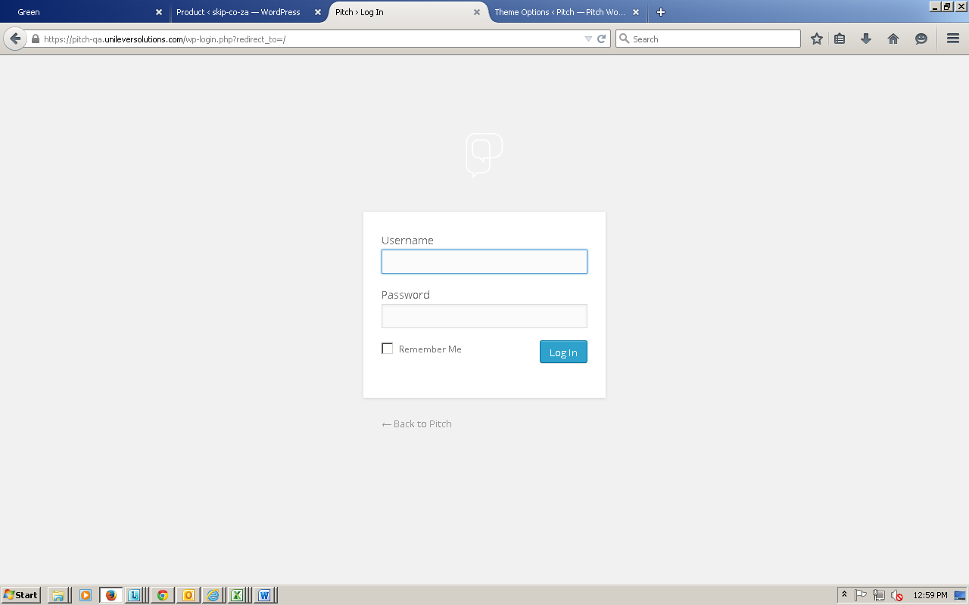

1. Enter the admin credentials

Username: testpitchlondon

Password: pitch@dm1n

1. Click **Log In**

# High Priority Amendments

## ID 1: Per-Location Traffic Manager Emails

All communications to and from a location should be routed through that location’s traffic manger

* [Pitch.London@unilever.com](mailto:Pitch.London@unilever.com)
* [Pitch.NYC@Unilever.com](mailto:Pitch.NYC@Unilever.com)

**User Type:** Default

1. Login to staging environment (<https://pitch1-uat.unileversolutions.com/wp-login.php>)

Username: testpitchvisitor

Password: pitch@dm1n

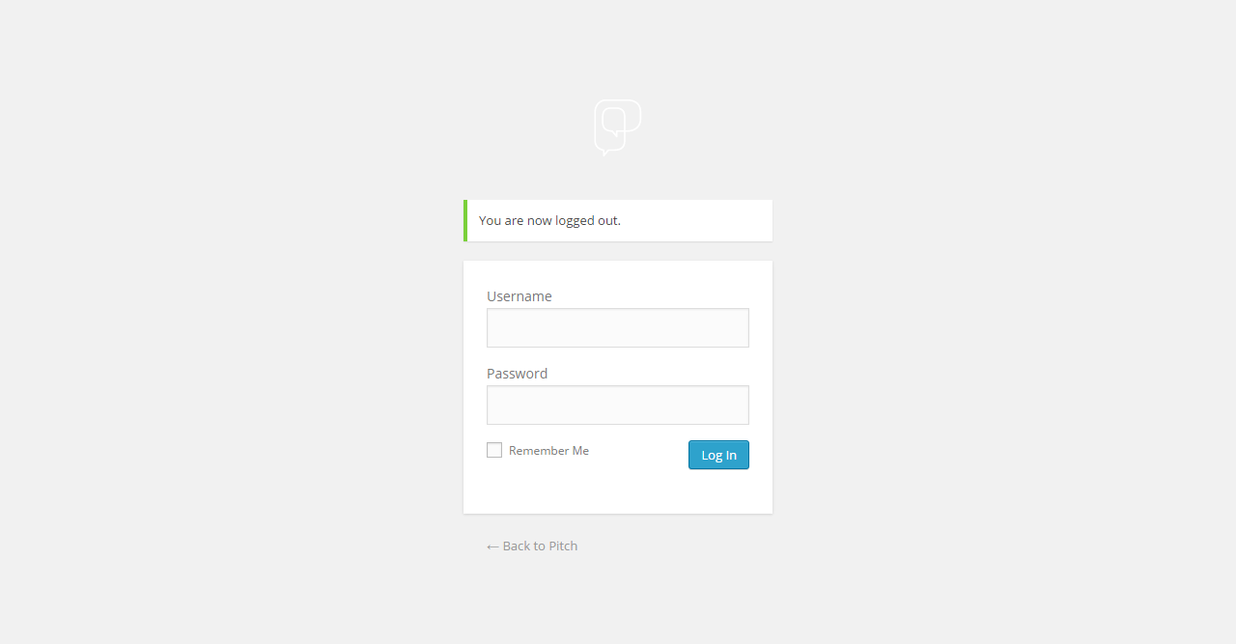

1. Click on **VISIT SITE** to navigate to the Home Page

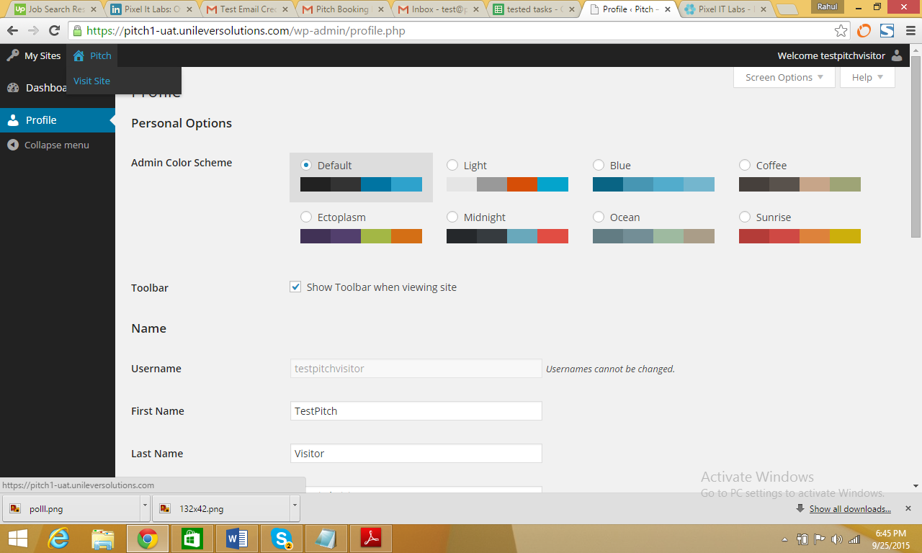

1. Click on **BOOK A WORKSHOP** page

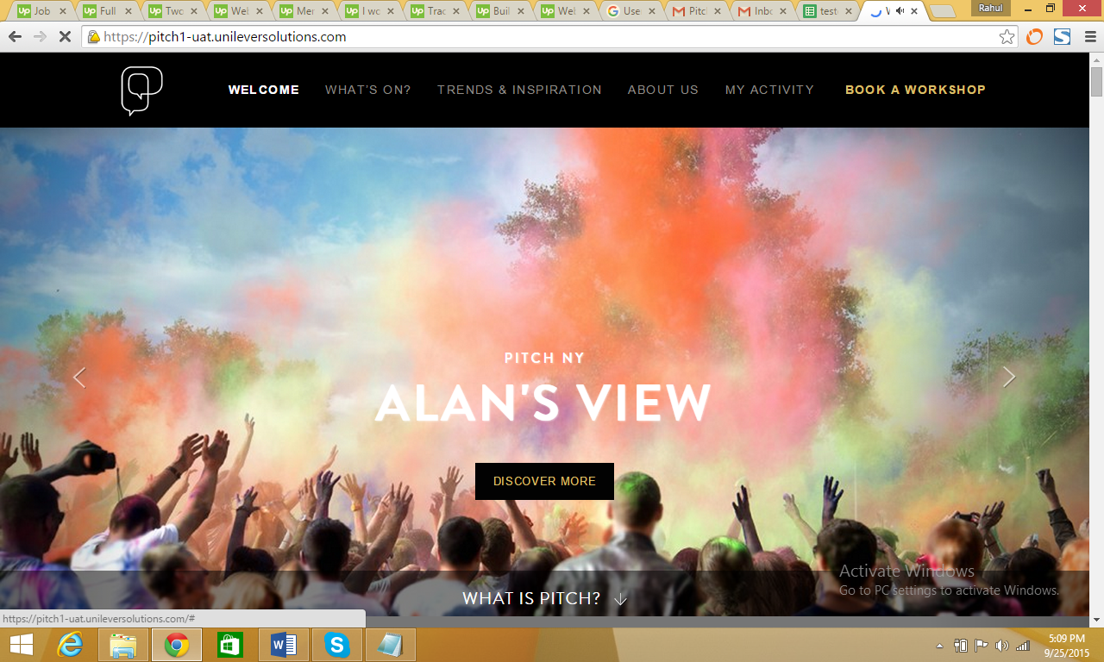

1. On the **BOOK A WORKSHOP** page, select a date when the **FULL PITCH SERVICE** is available. For example, select any date from December 2015

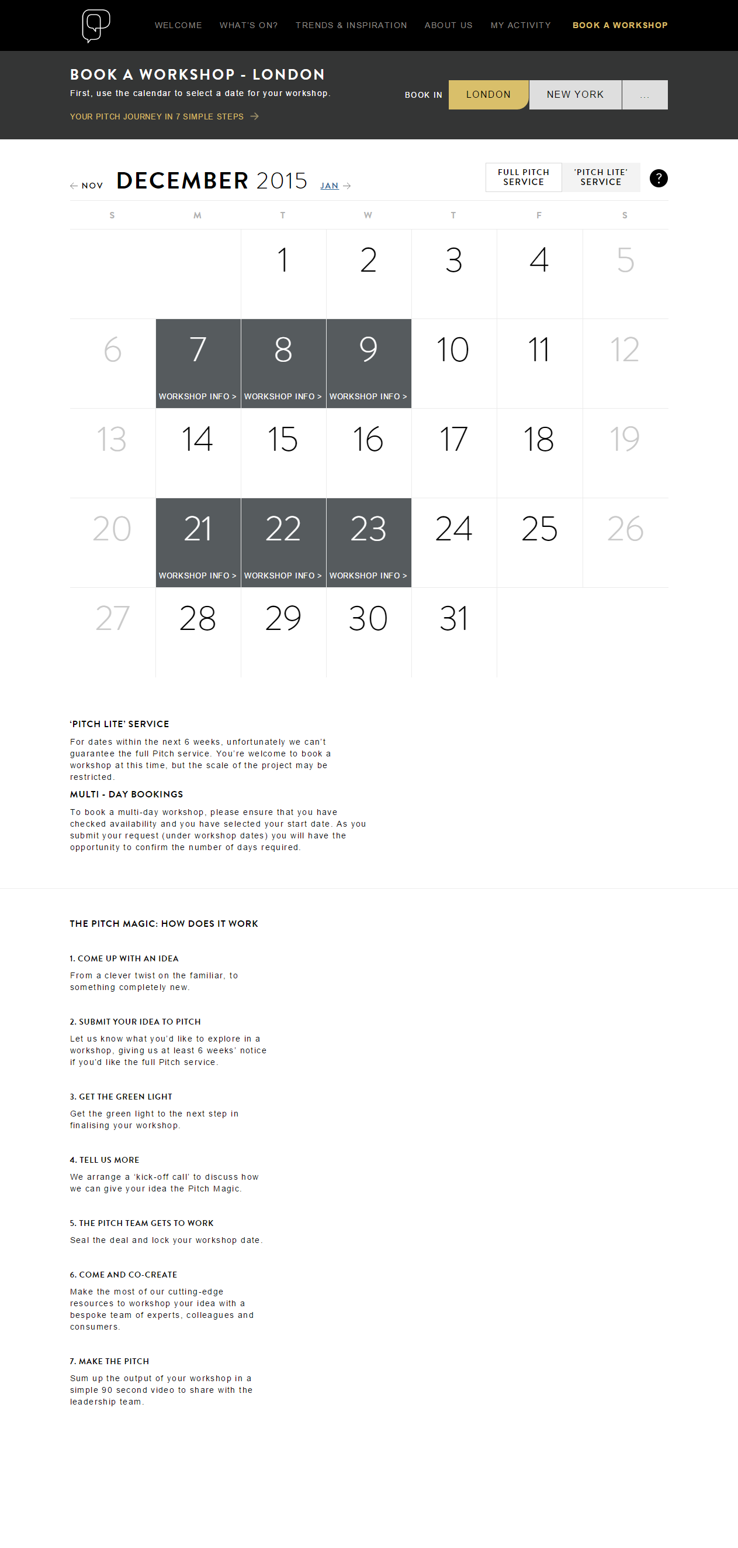

1. When the booking page is open, please fill out the complete form & Submit your request

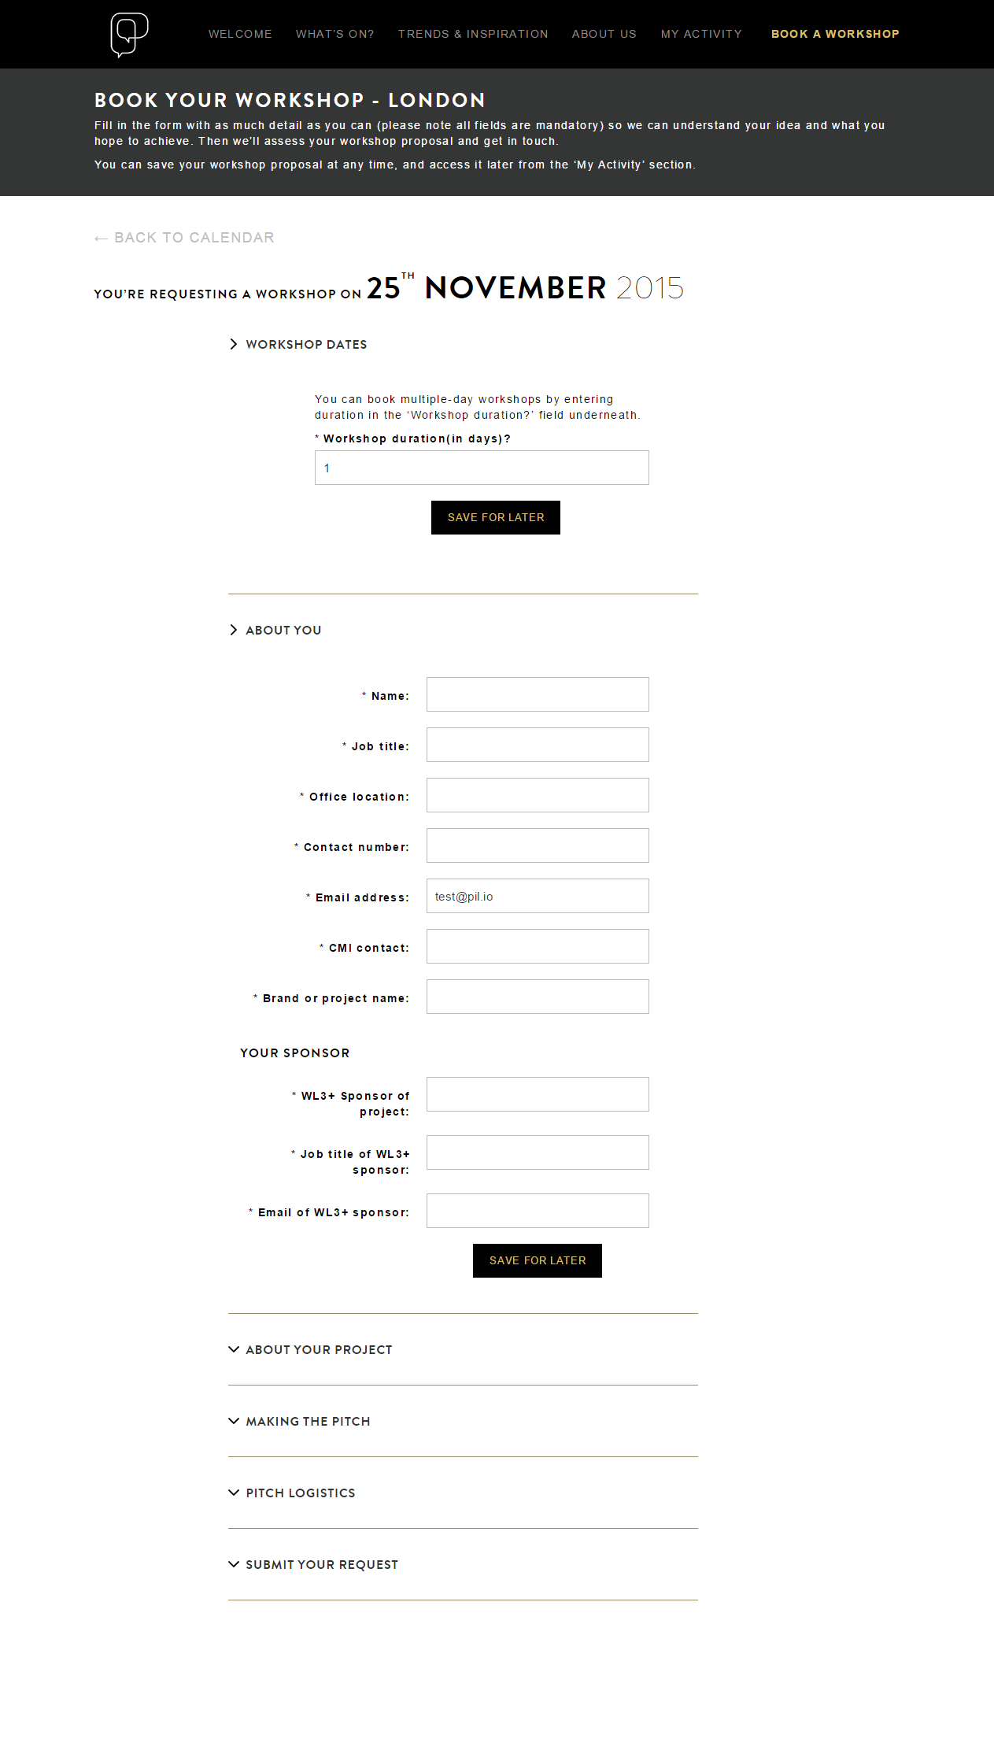

1. Booking Confirmation message will appear

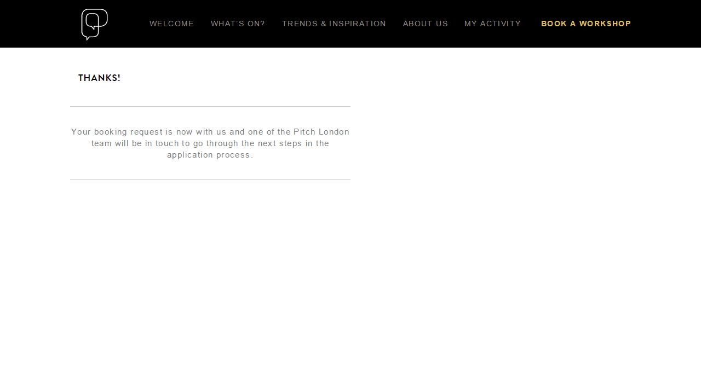

1. Please log in to the registered email for the default user and you can see that the booking confirmation notification has arrived from the traffic manager email ID

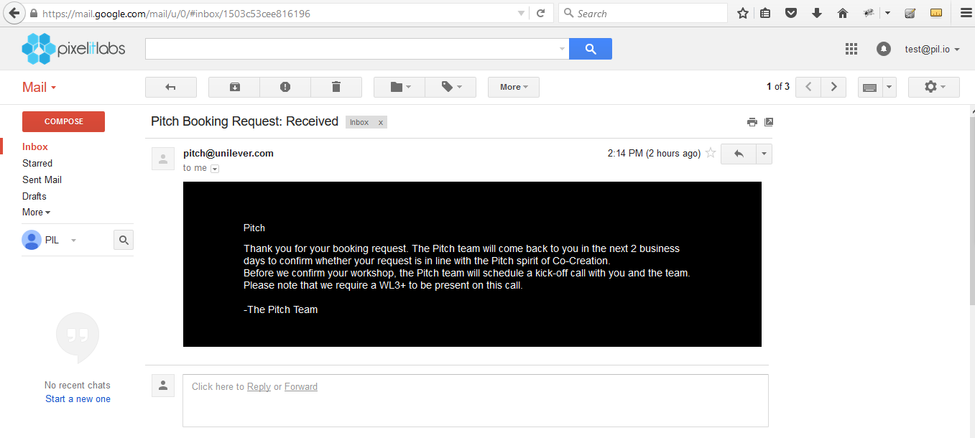

## ID 16, 34: Quick Book Process

- Create a simple ‘quick booking’ process that the traffic manager can use to block the day and make it non-bookable

- Allow this for the traffic manager role and give them a quick-book functionality on the calendar view so they can block a day

- Shortcut to enable Traffic Manager to block day from the calendar - without having to fill in the complete workshop form

**User Type:** Traffic Manager (NYC or London)

1. Log in as pitch admin using the following URL (<https://pitch1-uat.unileversolutions.com/wp-admin/>)

Username: testpitchlondon

Password: pitch@dm1n



1. Click on the **VISIT SITE** option available in the dashboard

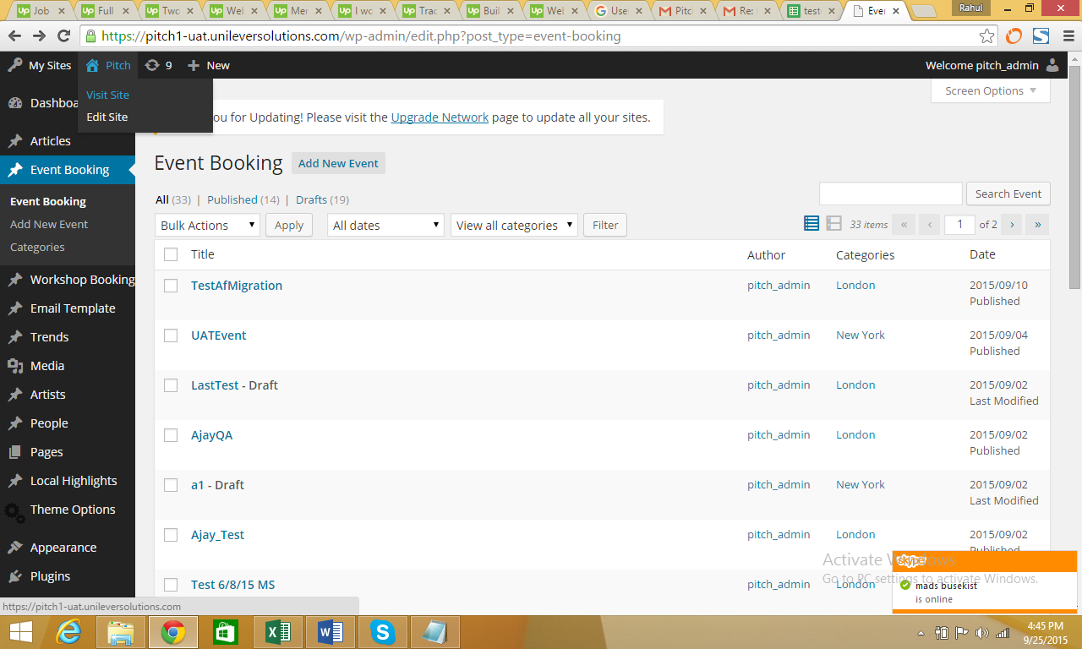

1. On the Home Page click on **BOOK A WORKSHOP** option



1. On the **BOOK A WORKSHOP** page, select a date when the **FULL PITCH SERVICE** is available. For example, select any date from December 2015



1. For the next page, you can **QUICK BOOK** multiple-day workshops by entering the duration in the **WORKSHOP DURATION** option

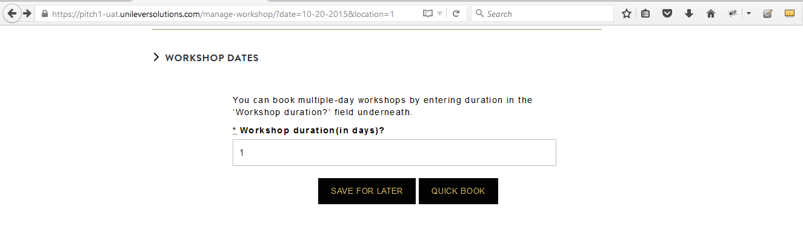

1. From this page, you can enter the Quick Book Title and Workshop duration (in days), then click the **QUICK BOOK** button to complete booking

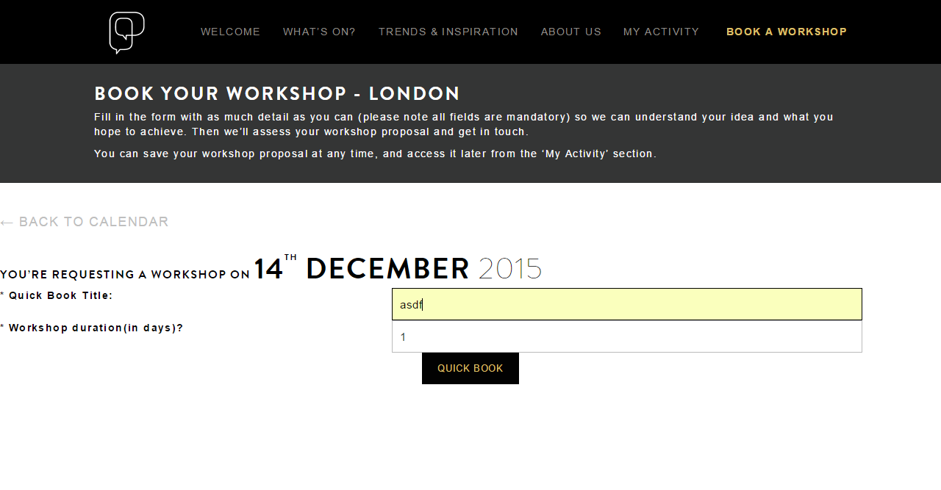

1. You will then land on the final Booking Confirmation page. The confirmed booking status can be seen on the top right corner of the confirmation page

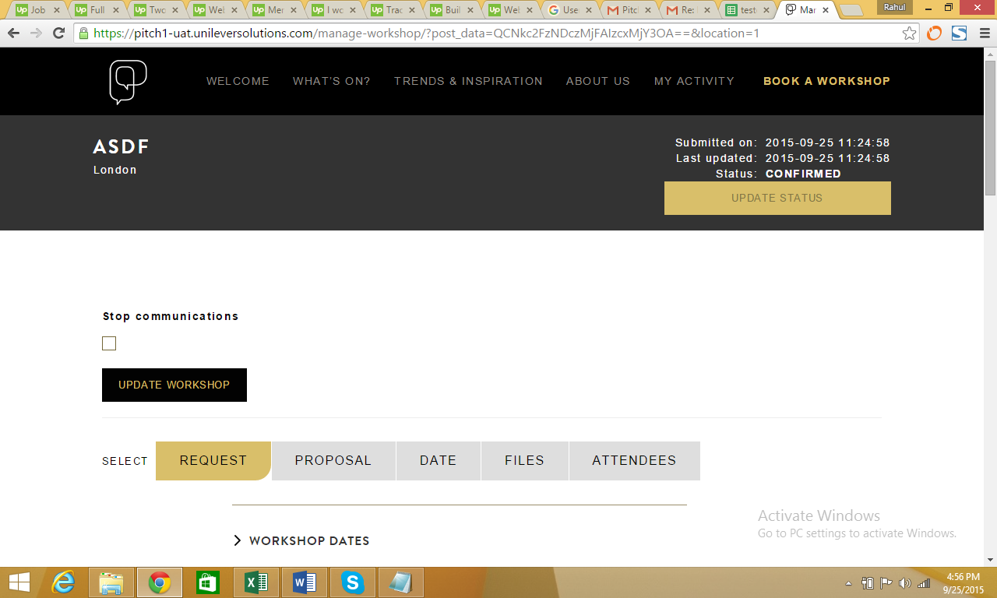

## ID 19: Booking Brief Update Error

Ability for Pitch to edit the brief that is submitted by the Booking Requester

**User Type:** Traffic Manager (NYC or London)

1. Log in as pitch admin using the following URL (<https://pitch1-uat.unileversolutions.com/wp-admin/>)

Username: testpitchlondon  
Password: test@dm1n



1. Click on the **VISIT SITE** option available in the dashboard



1. On the Home Page, click on **BOOK A WORKSHOP** Option



1. Select any active workshop from the calendar.

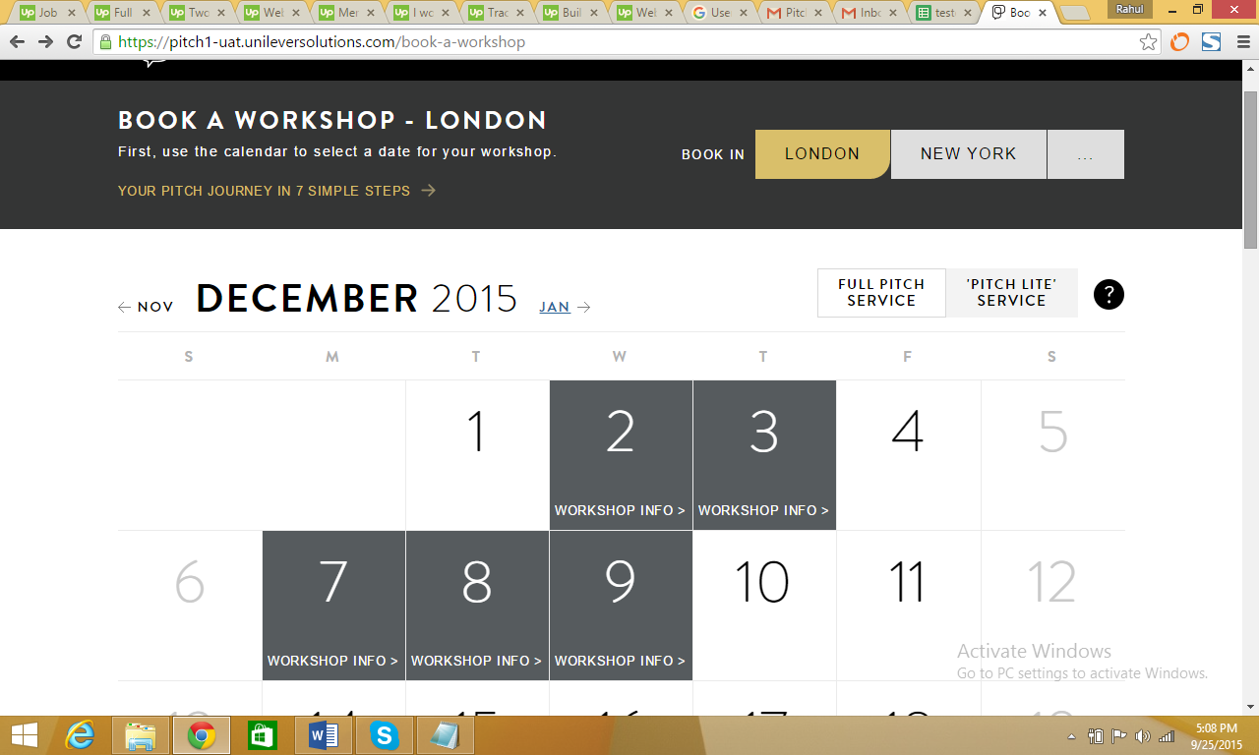

1. Once you land on the Manage Workshop page, click the **REQUEST** tab and edit the fields as per the requirement and click **Submit My Workshop proposal**

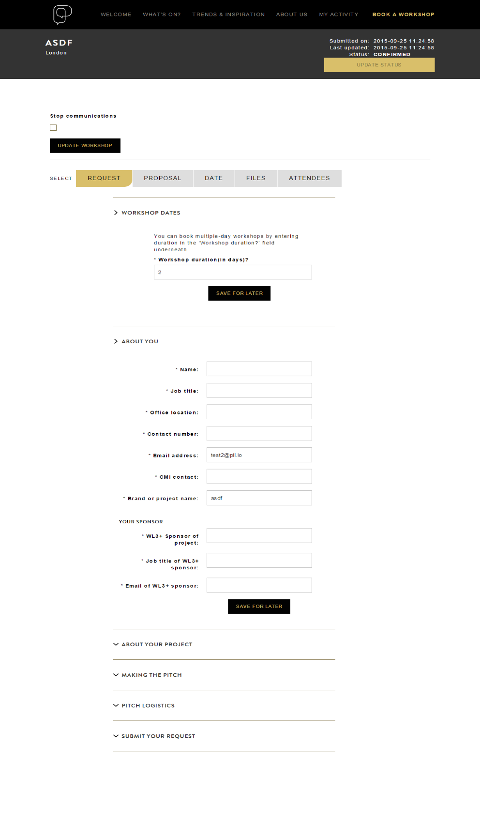

1. The “Workshop request has been updated” will be displayed

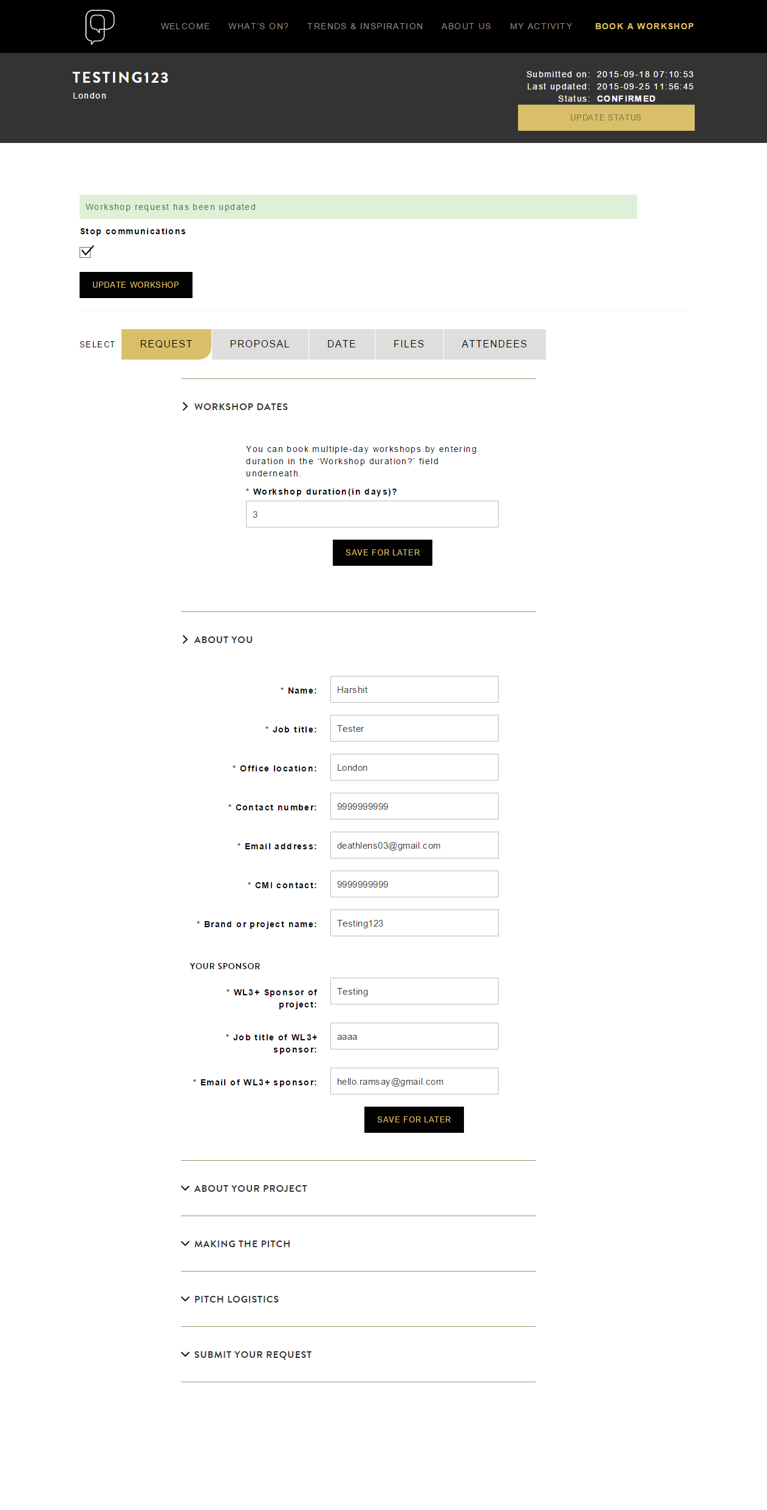

## ID 39: Website Automated Emails

Change the copy on line 4 – to clarify that the Pitch team will set up the kickoff call. Several people have thought it’s their responsibility to set up the KO call. So let’s change the copy to read as follows: Before we confirm your workshop, the Pitch team will schedule a kick-off call with you and the team. Please note that we require a WL3+ to be present on this call.

**User Type:** Traffic Manager (NYC or London), Default User

1. Review the content on the email image below

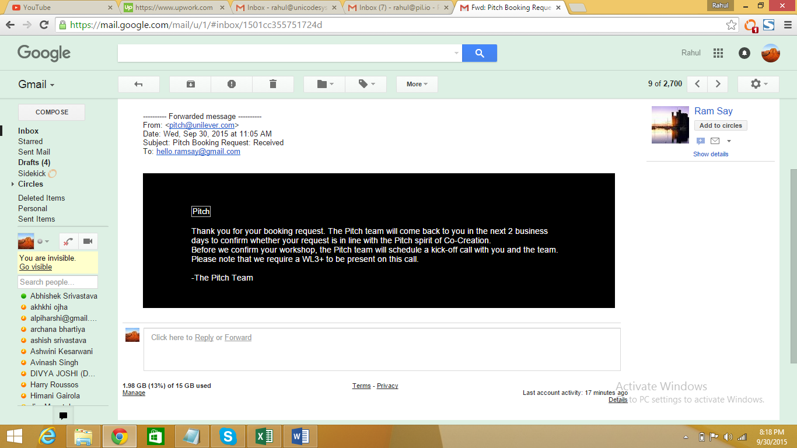

## ID 41: Content Update

Is there a way to ensure that the User Mike shows up as “Michael Fortner” instead of “michael.fortner3” on the emails that are sent out when a workshop is confirmed? Same for anyone else in the future whose name is not his or her email address?

**User Type:** All

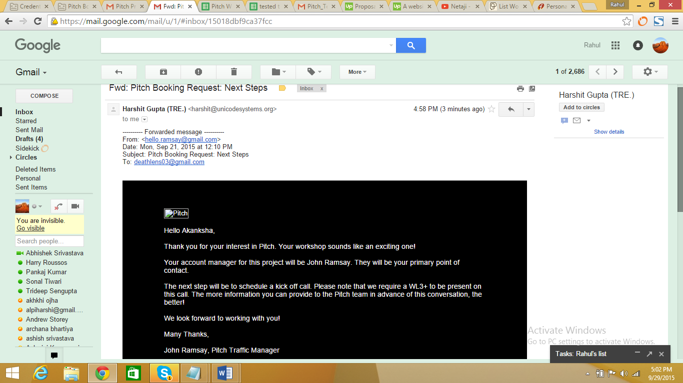

## ID 43: Enhancements

When we receive a new workshop request, there is an automated email that’s generated for the Pitch.NYC email address. However it always gets stuck in the spam folder, and when we move the email to the inbox, we aren’t able to read it to understand who requested, what dates, etc.

**User Type:** All

Check the screenshot below. This is a copy of an email, which is sent to the new workshop request and test ID’s that we are using, it will no longer appear in the spam folder. We may have to check this with the actual Pitch NYC and London email IDs for further confirmation.

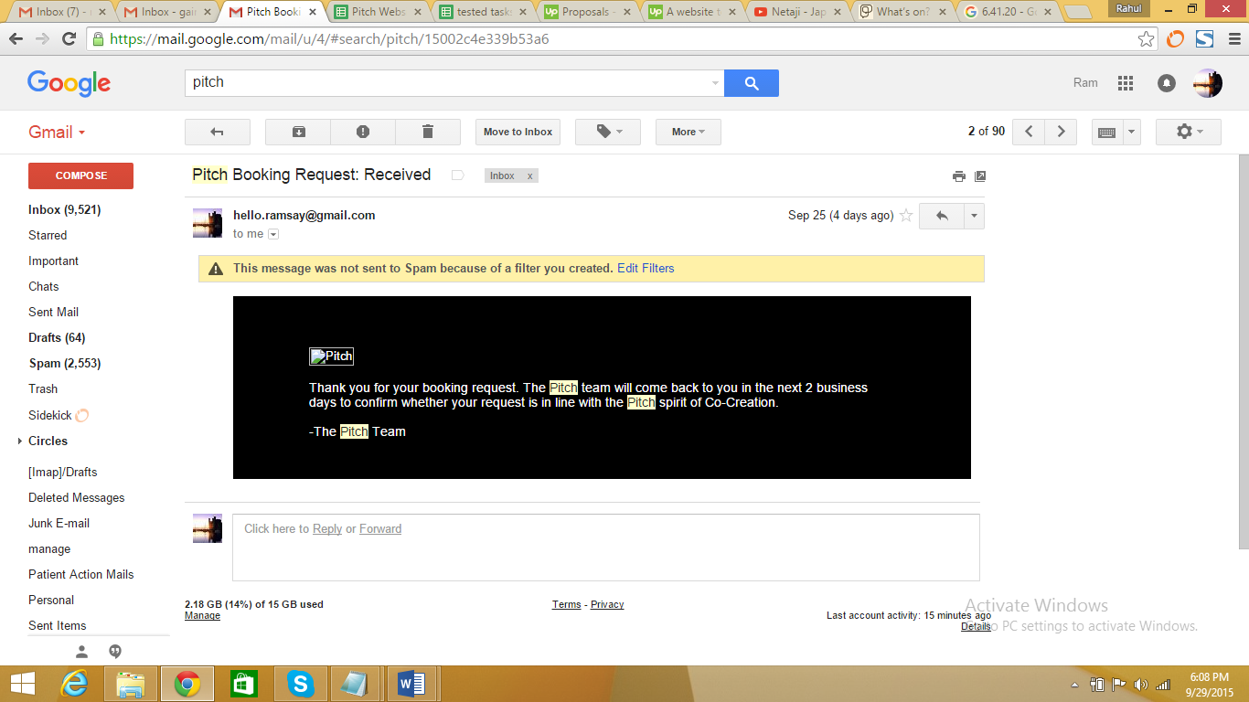

## ID 40: On the Submission Form

We need to add a mandatory field: <Copy>Expected ITO or Business Opportunity</Copy>

**User Type:** Default User, Traffic Manager (NYC or London)

1. Please login as a user from the following screen (<https://pitch1-uat.unileversolutions.com/wp-login.php>)

Username: testpitchlondon

Password: pitch@dm1n



1. Click on **VISIT SITE** to navigate to the Home Page



1. Click on **BOOK A WORKSHOP** option on the home page

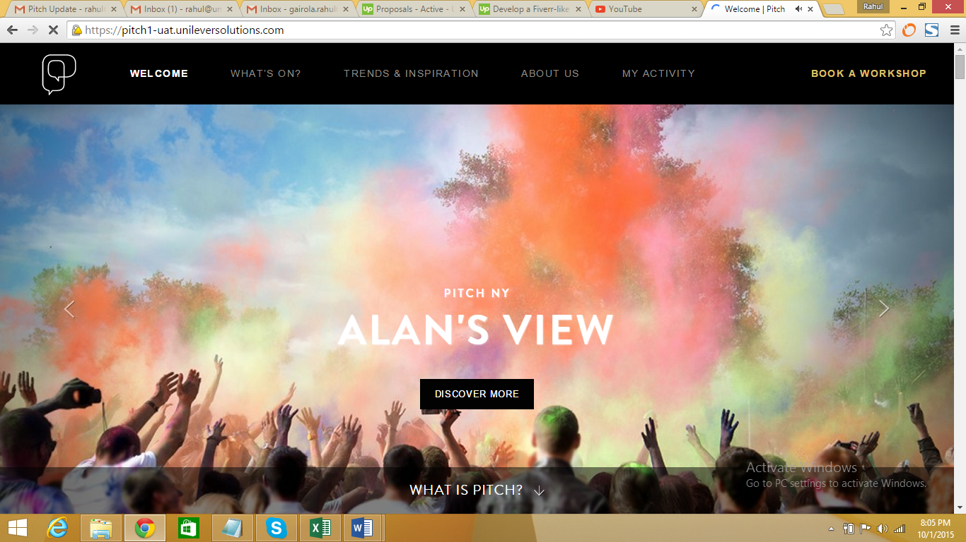

1. Select a date from the calendar on which **FULL PITCH SERVICE** is available

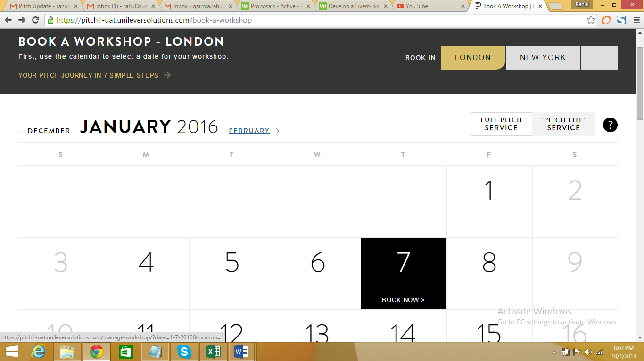

1. On the following page you can see field “Expected ITO or Business Opportunity”

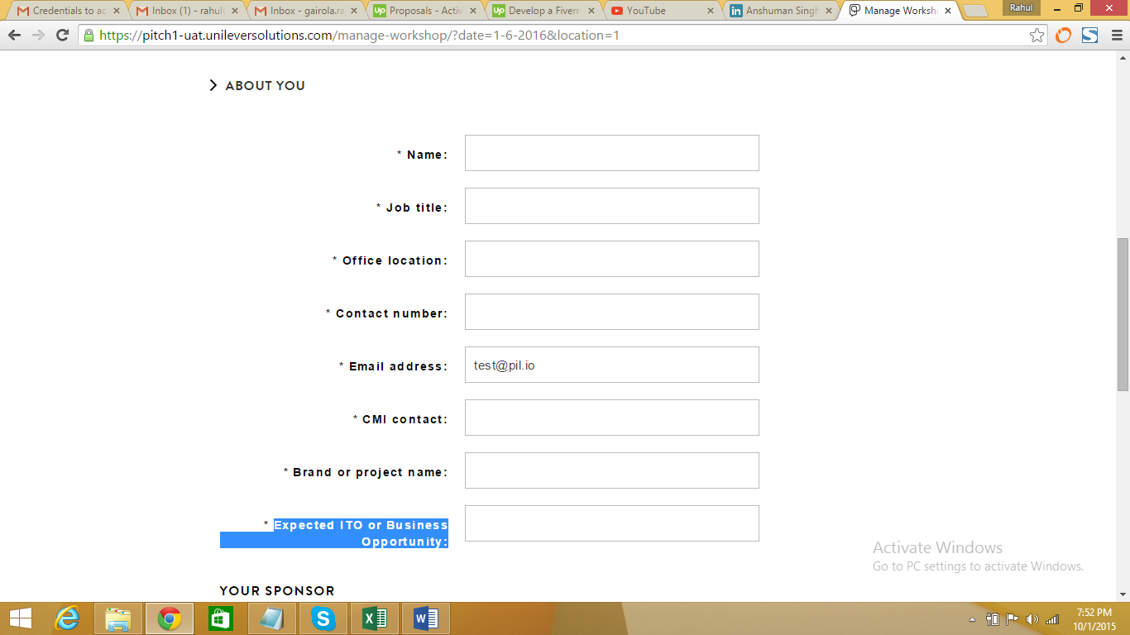

# Medium Priority Amendments

## ID 4: Unique URLs Per Tab

Ensure that each location tab across all pages is handled as a separate URL  
*i.e., this would allow the NYC About Us page URL to be different London, even though it's on the same page*

**User Type:** Default

Username: testpitchvisitor  
Password: pitch@dm1n

1. Go to **ABOUT US** page and select your location as ‘**London’** and then check the URL. The user will see the URL changing

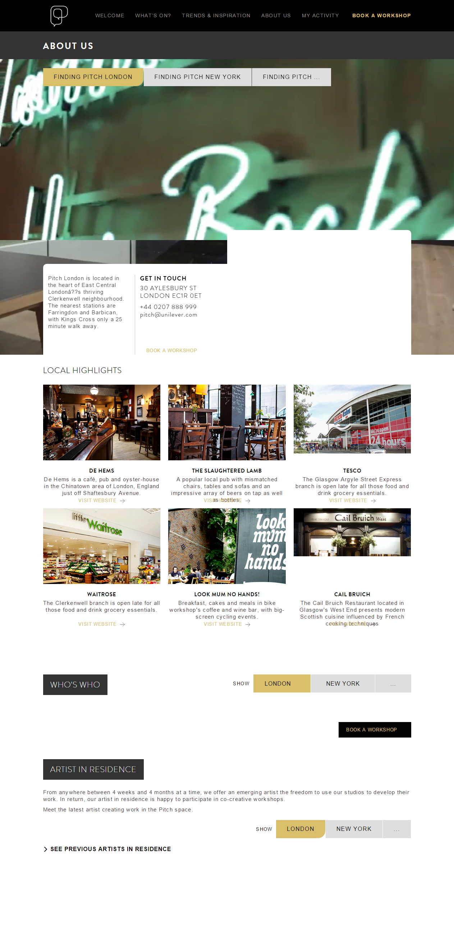

1. Continue onto the same page and select the location as New York and then check the URL. The user will see the URL changing

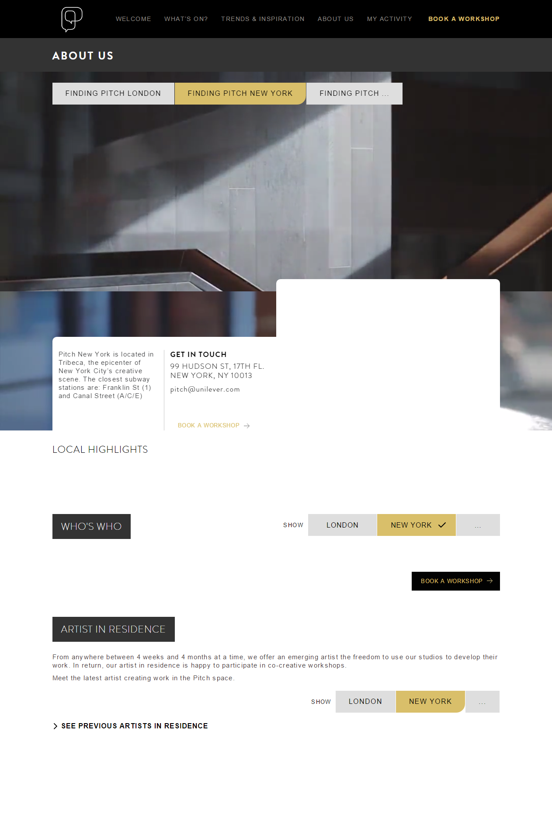

## ID 18: Remember and Utilize Tab Selection Per Session

(Per session) When a user selects a location tab on any page of the site, remember that selection and use it as the default location for all other pages during the user's session. If - during the same session - the user chooses a different location, remember that selection.

**User Type:** All Users

1. Please login as a user from the following screen (<https://pitch1-uat.unileversolutions.com/wp-login.php>)

Username: testpitchlondon / testpitchvisitor

Password: pitch@dm1n



1. Click on **VISIT SITE** to navigate to the Home Page



1. Click on “About Us” option on the home page and then from the following page select **FINDING PITCH LONDON**

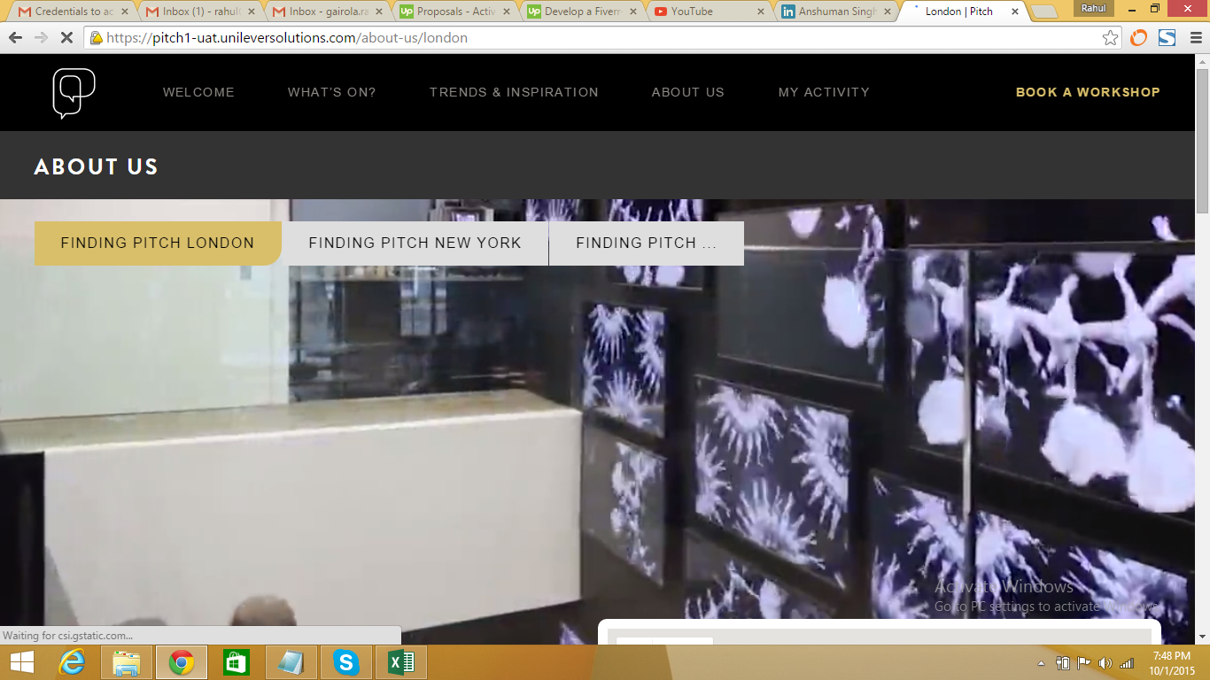

1. Now click on **WHATS ON** page and you will see that **LONDON** is selected by default

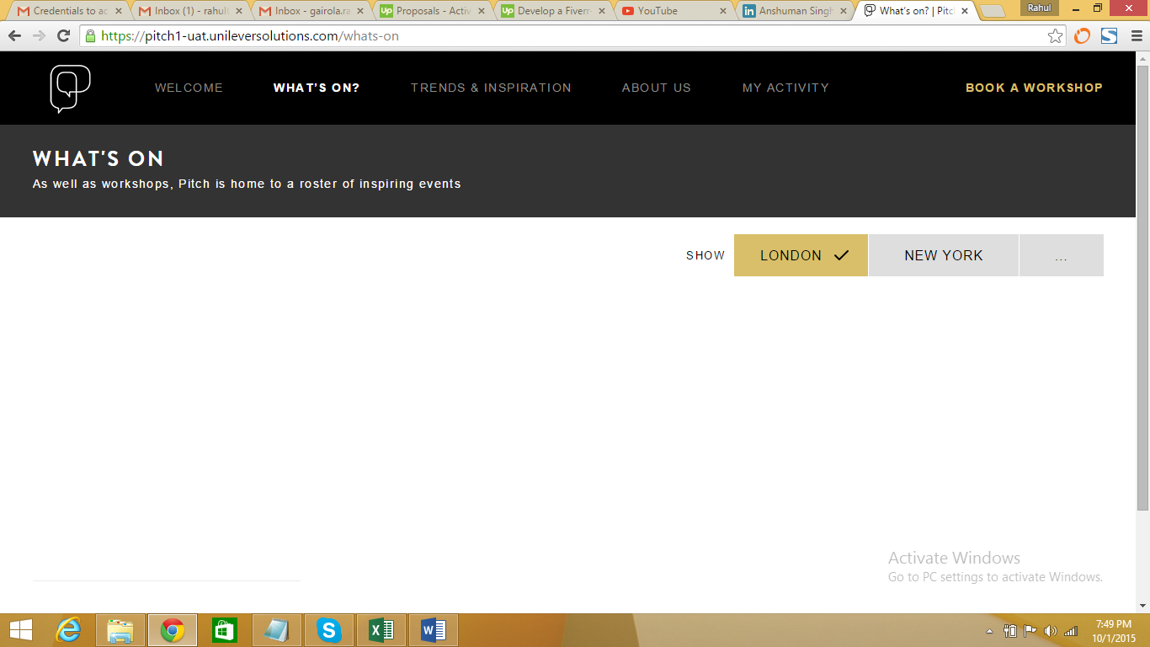

## ID 18: No Comms Process

Allow a new 'Stop communications?’ function for bookings on the edit booking screens, so that the Pitch team can progress a booking to confirmed status without sending notifications to the attendees

Can we add an option to bypass automated emails? Because in some cases, I have been playing catch-up and confirming workshops after the kickoff call – so would like to alleviate any confusion that arises from the automated emails being sent to directors and VPs.

**User Type:** Traffic Manager (NYC or London)

1. Log in as pitch admin using the following URL (<https://pitch1-uat.unileversolutions.com/wp-admin/>)

Username: testpitchlondon  
Password: pitch@dm1n



1. Click on the **VISIT SITE** option available in the dashboard



1. Click on **BOOK A WORKSHOP** Option



1. Select any active workshop from the calendar



1. Check the stop communication box and click on **UPDATE WORKSHOP** to stop email communication

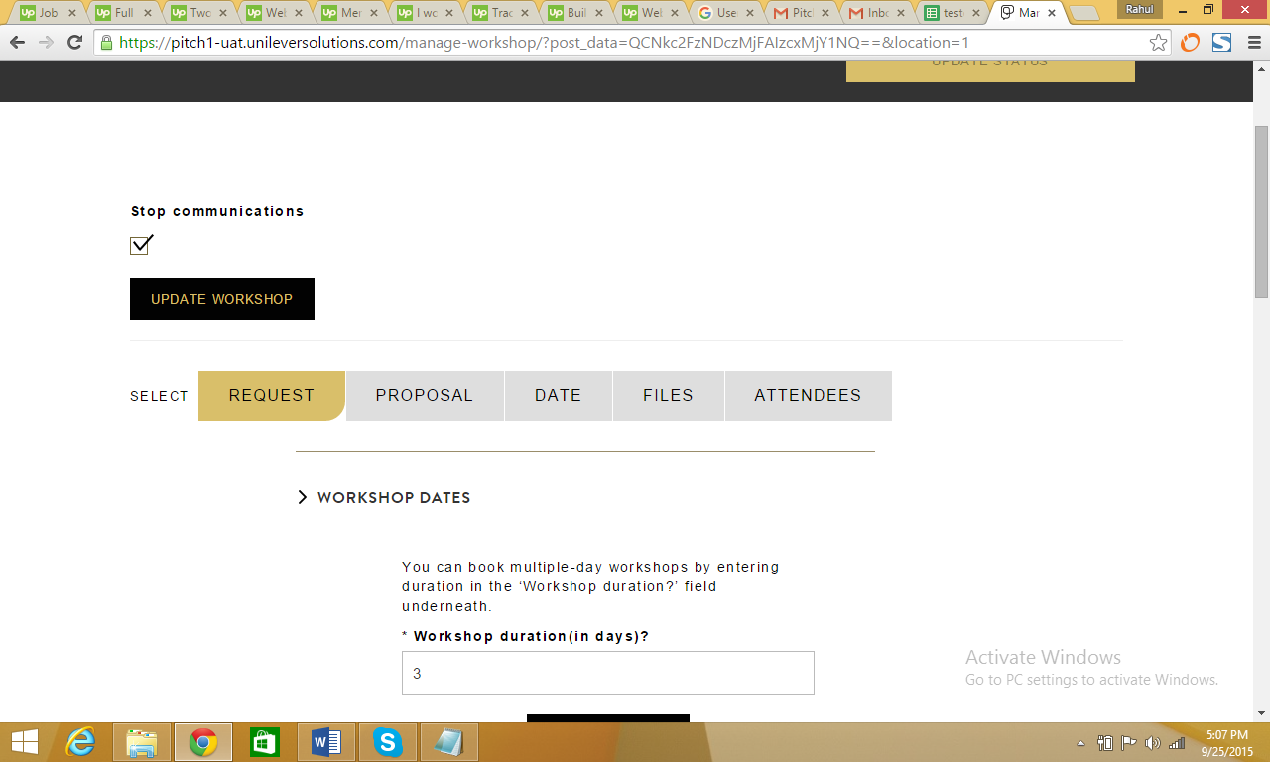

## ID 24: Change of Event/Workshop

If a workshop/event date changes, it needs to be deleted and added again - therefore the user needs to go through the manual process fully again

**User Type:** Traffic Manager (NYC or London)

1. Log in as pitch admin using the following URL (<https://pitch1-uat.unileversolutions.com/wp-admin/>)

Username: testpitchlondon

Password: pitch@dm1n

1. After successful login, Click on the **VISIT SITE** option available in the dashboard
2. On the Home Page, click on **BOOK A WORKSHOP** Option
3. On the **BOOK A WORKSHOP** page, select a date that has already been booked and when the **FULL PITCH SERVICE** is available. For example, select any booked date from December 2015
4. Click on **DATE** tab

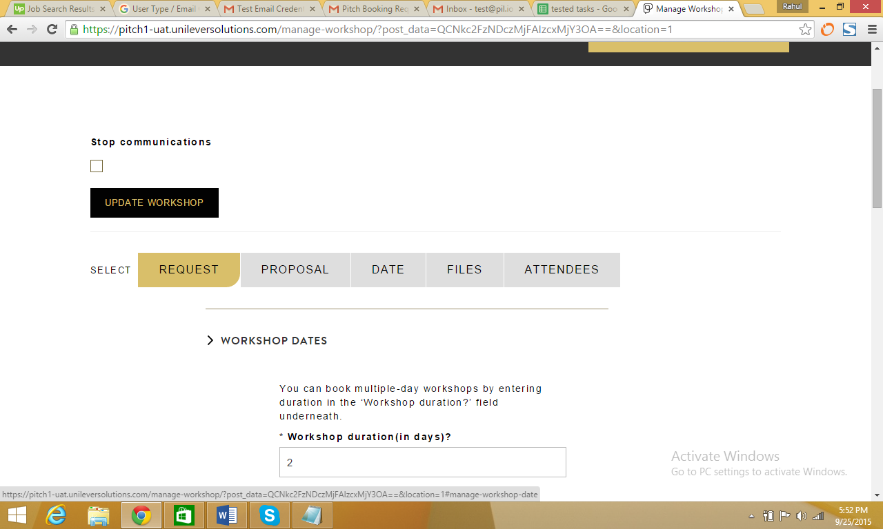

1. Change the workshop start date and click on **UPDATE WORKSHOP**

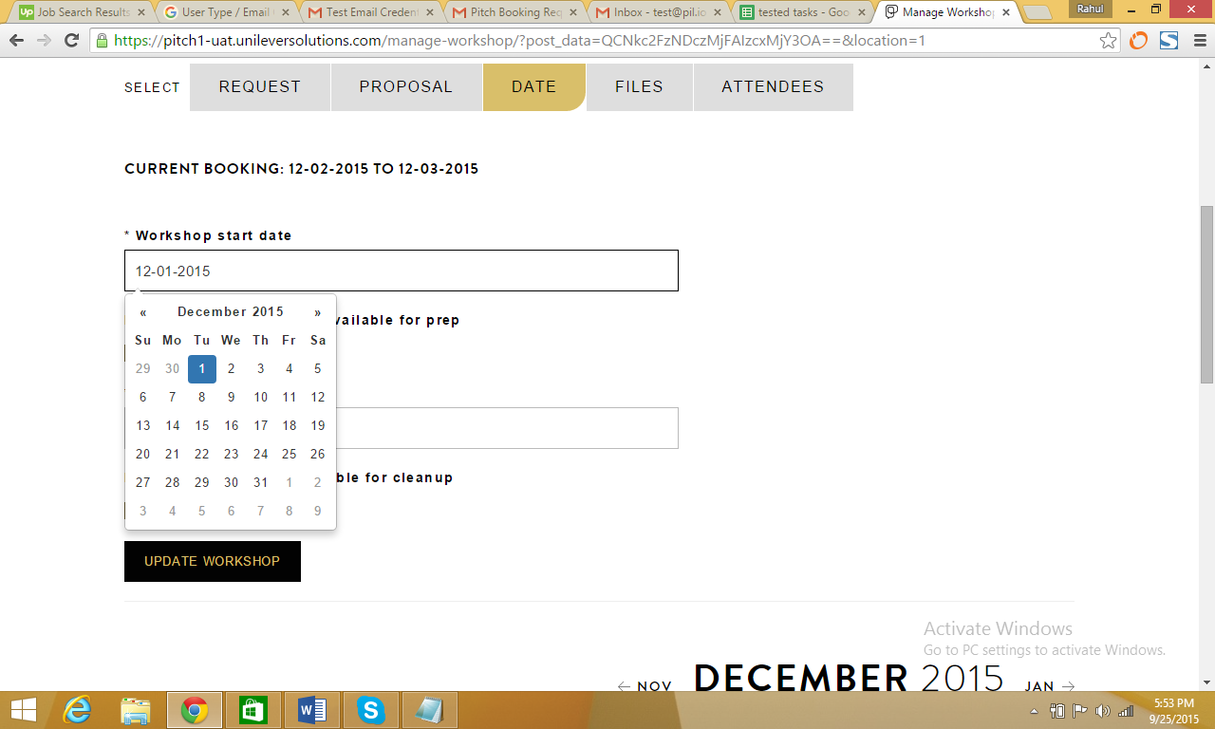

1. “Workshop dates have been updated” confirmation message will be displayed

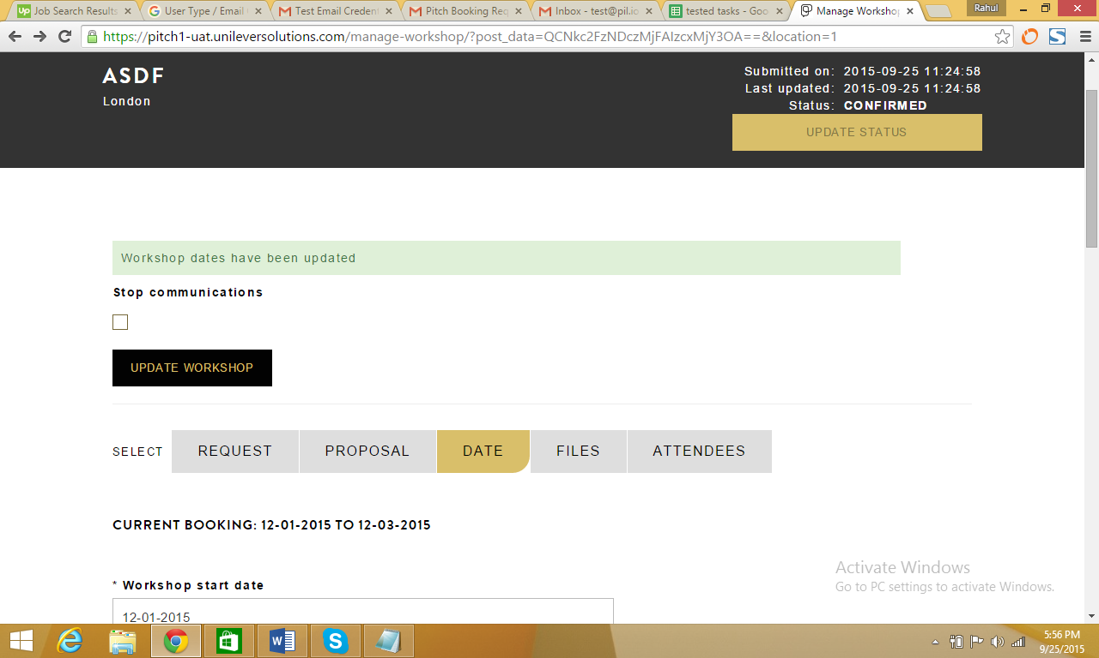

## ID 20: Booking Invite Formatting

Improve the formatting of the booking invite Emails that is sent to delegates (e.g. attendees)   
• currently, the calendar file attached to the invite has a strange title and looks illegitimate

**User Type:** Default User

1. Review formatting in the screenshot below

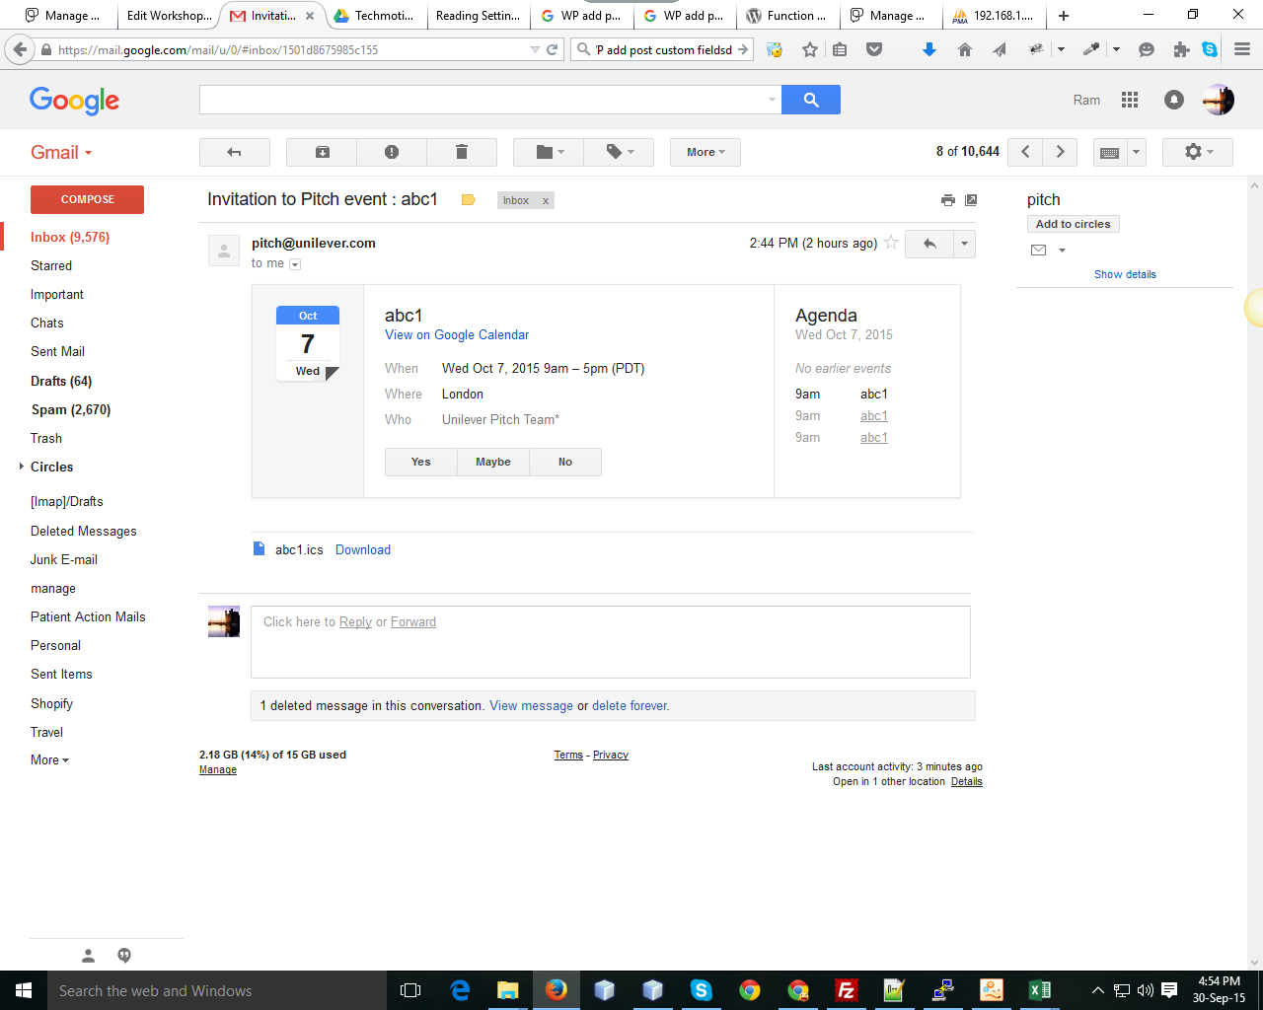

## ID 26: Manage Workshop Booking Date

In the ‘manage workshop’ section on both the front end and CMS, show a field for the booking’s date(s) – at present just a code.

**User Type:** Traffic Manager (NYC or London), Default User

Username: testpitchlondon | testpitchvisitor

Password: test@dm1n

1. Please log in as a user from the following screen (<https://pitch1-uat.unileversolutions.com/wp-login.php>)

Username: testpitchlondon | testpitchvisitor

Password: test@dm1n



1. Click on **VISIT SITE** to navigate to the Home Page



1. Click on **MANAGE WORKSHOPS** option on the home page

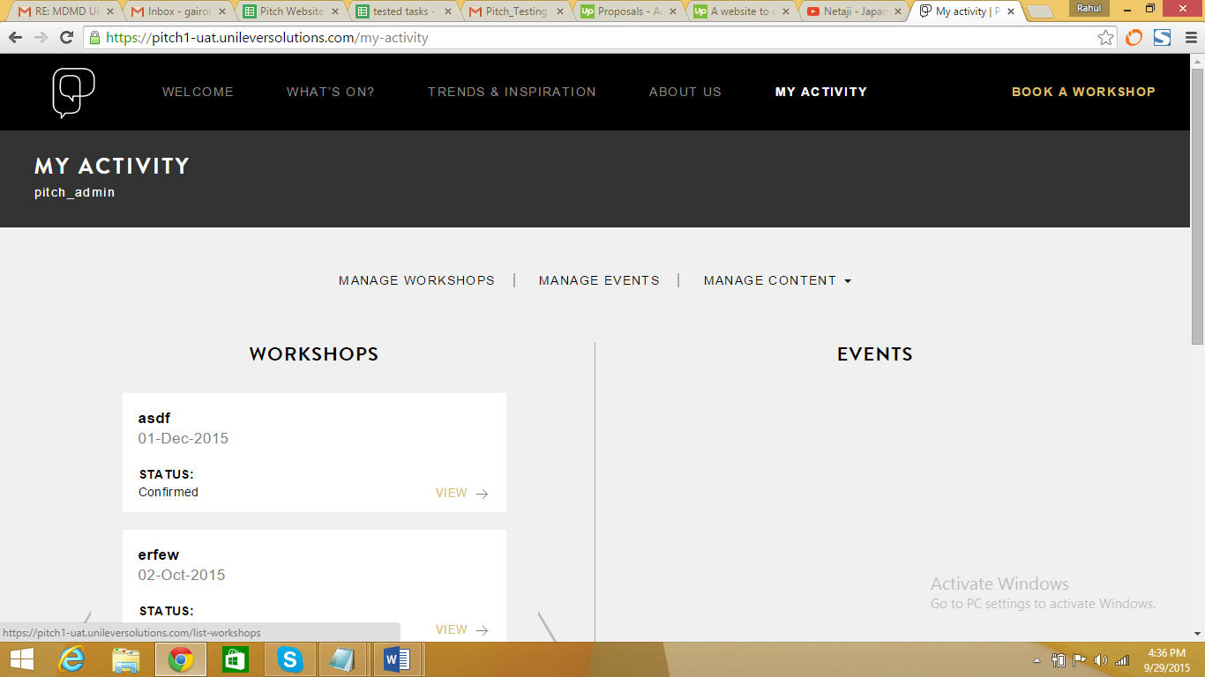

1. Select any Project from **MANAGE WORKSHOPS** page

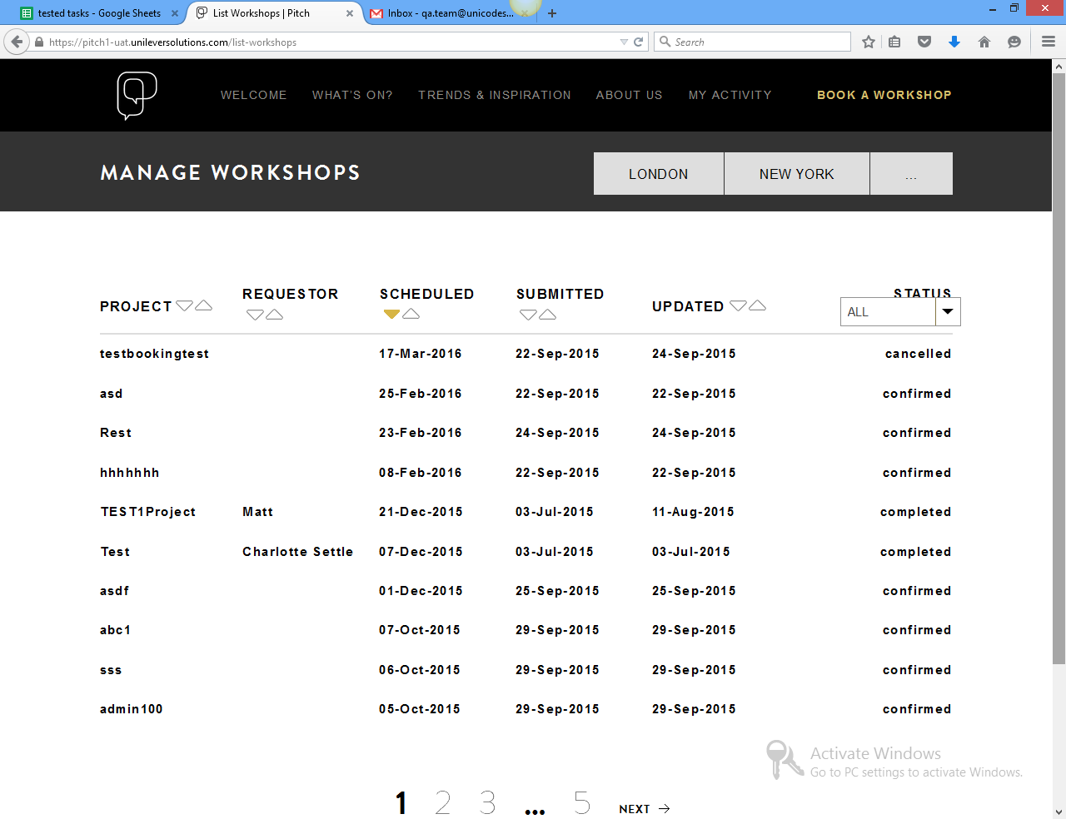

1. On the final page, user can now see dates instead of codes

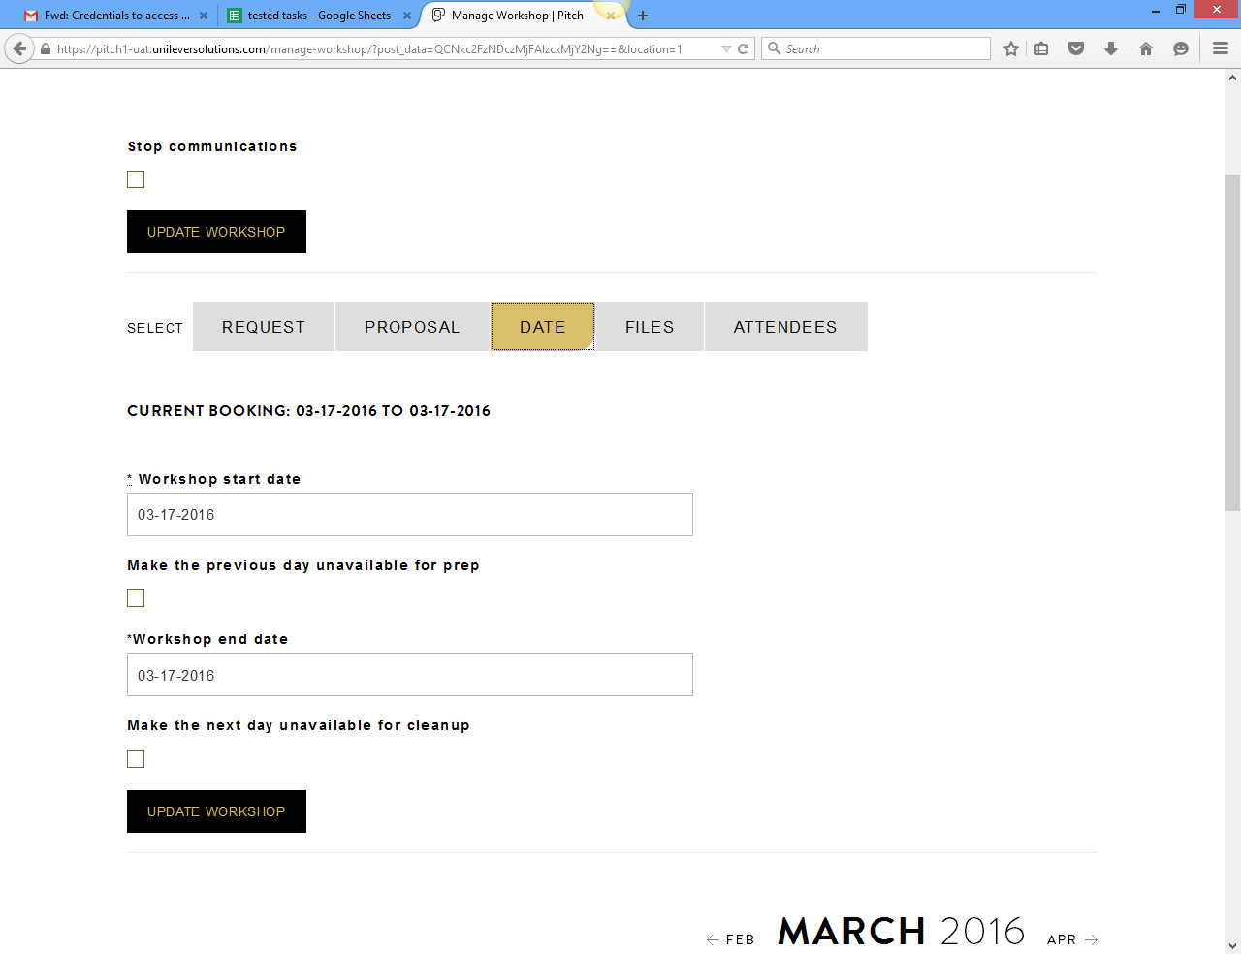

## ID 30: Trends Order

Trends materials should be displayed by the latest date of modification not aphetically display

**User Type:** Traffic Manager (NYC or London)

1. Log in as pitch admin using the following URL (<https://pitch1-uat.unileversolutions.com/wp-admin/>)

Username: testpitchlondon

Password: pitch@dm1n



1. Click on the **TRENDS** option available in the dashboard

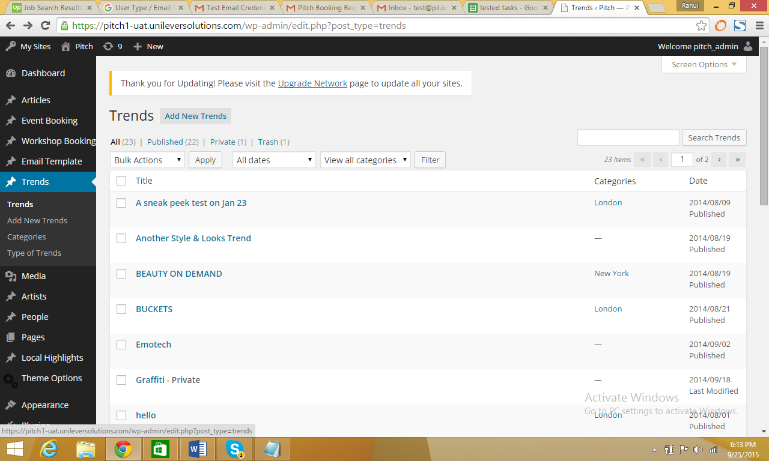

1. Click on **EDIT**

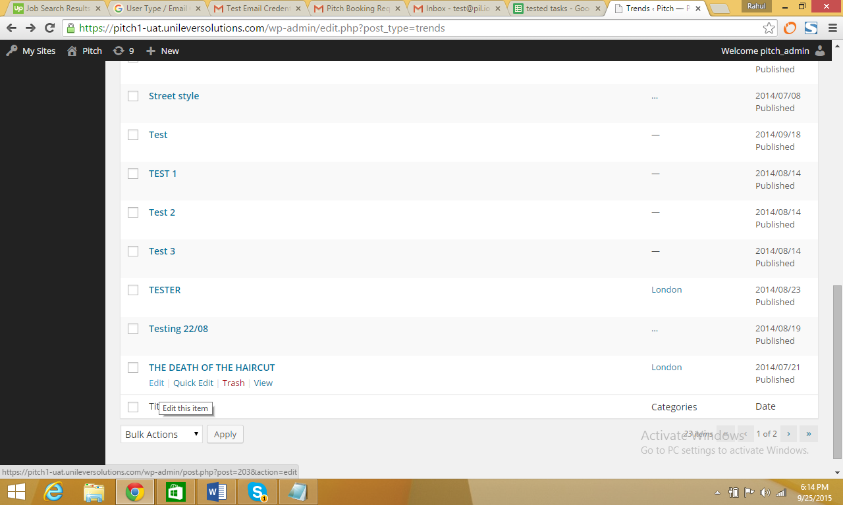

1. Make the changes and then click on **UPDATE**

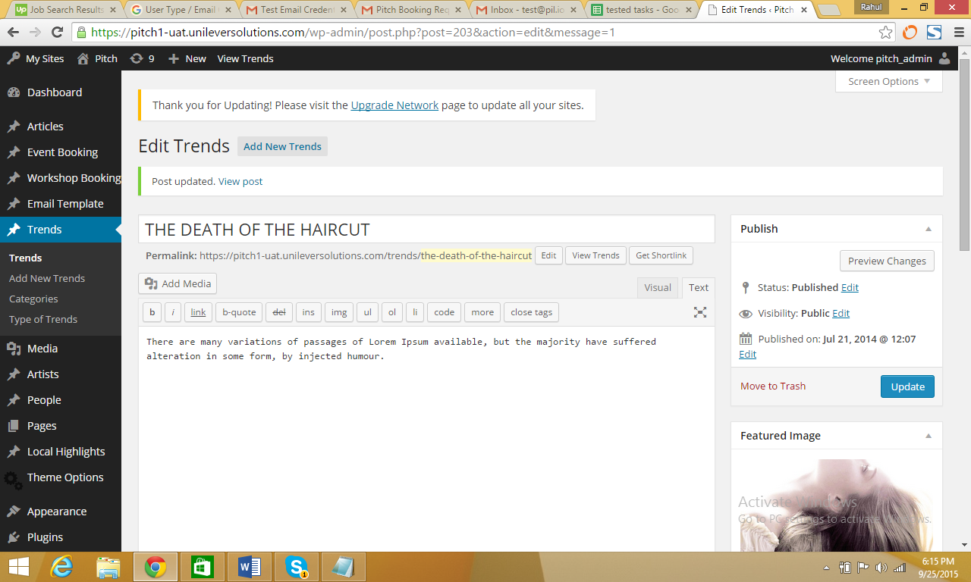

1. Click on **VISIT SITE** option on the dashboard

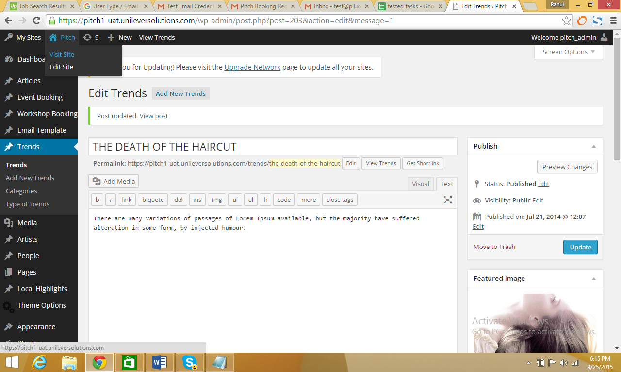

1. Click on **TRENDS & INSPIRATION** You can see the latest edited trend on the top of the page in first place



## ID 33: Un-editable Proposal Template in the Backend

In the templates section, you cannot edit the fields for users to submit proposal

**User Type:** Traffic Manager (NYC or London)

* 1. Log in as pitch admin using the following URL (<https://pitch1-uat.unileversolutions.com/wp-admin/>)

Username: testpitchlondon

Password: pitch@dm1n



* 1. Click on **EMAIL TEMPLATE**

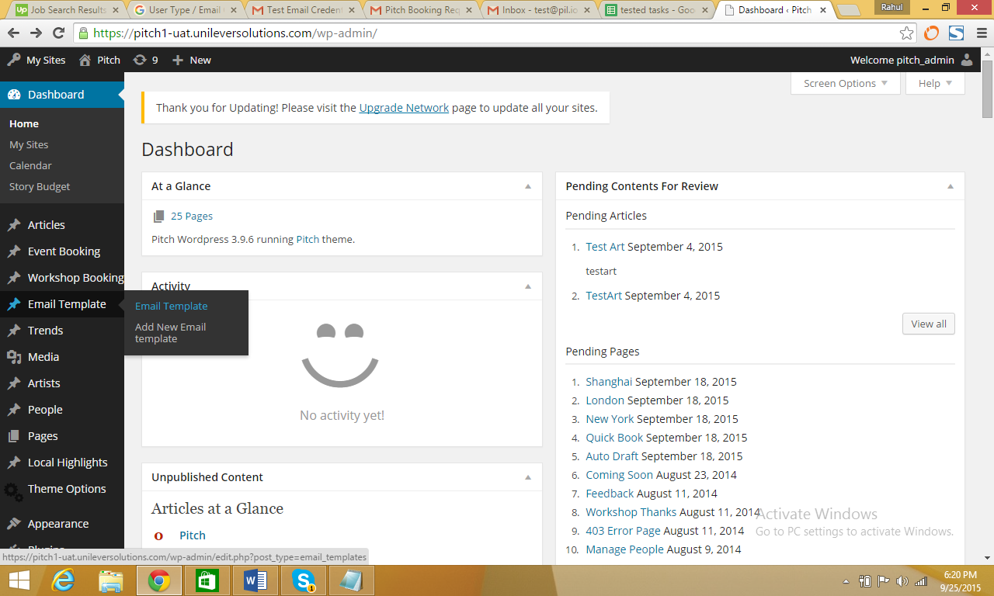

1. Click on **EDIT** to change the content of the respective email

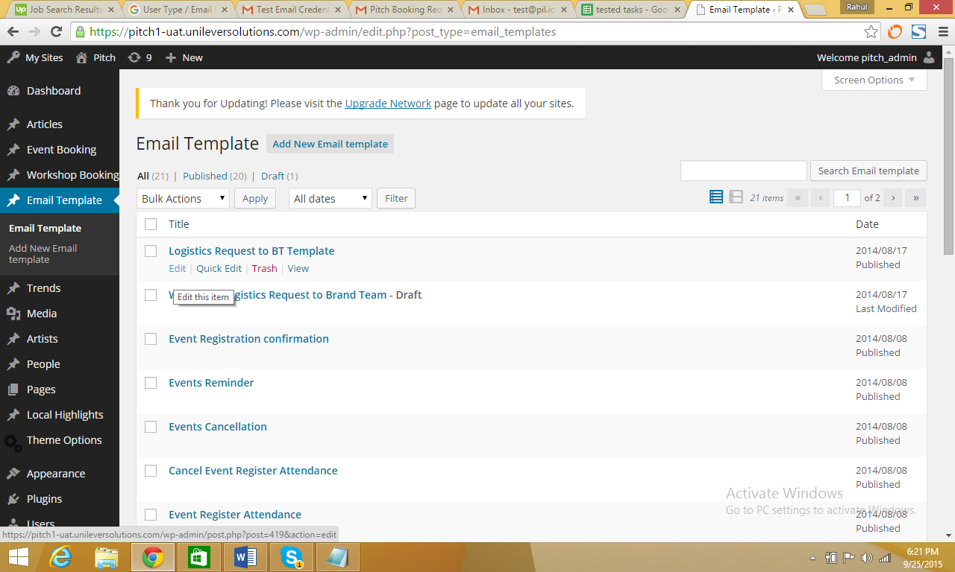

1. Make the changes and then click **UPDATE** and the changes you made will be saved and applied to the respective email template

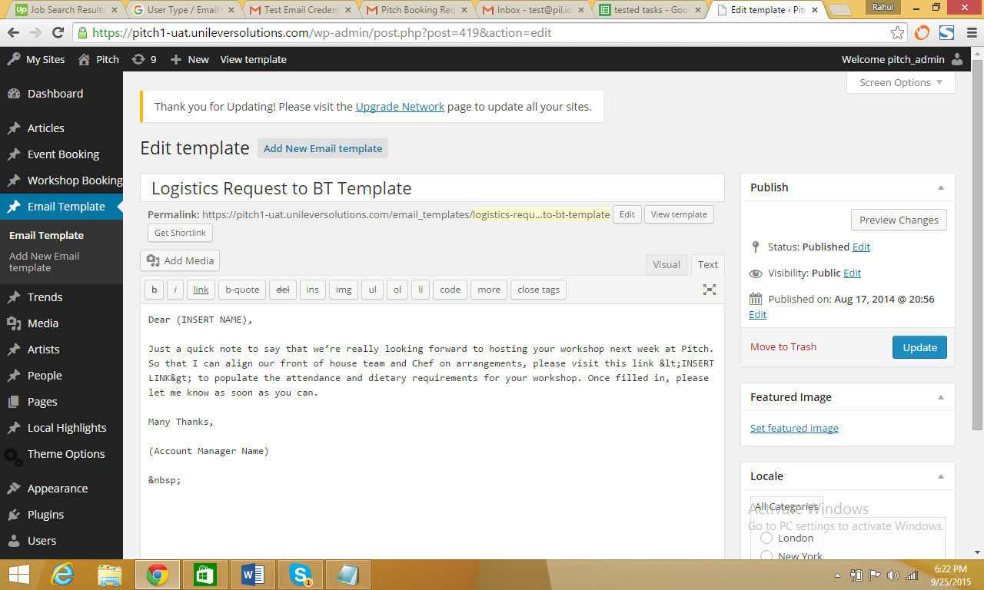

# Low Priority Amendments

## ID 29: 8MB Upload Limitation

Uploading materials on trends has a limit of 8mb - this is not enough as it compromises quality of upload

**User Type:** Traffic Manager (NYC or London)

1. Log in as pitch admin using the following URL (<https://pitch1-uat.unileversolutions.com/wp-admin/>)

Username: testpitchlondon

Password: pitch@dm1n



1. Click on the **ADD TRENDS** option available in the dashboard



1. On the **ADD TRENDS** page fill in the relevant details and upload a file more than 8MB in size

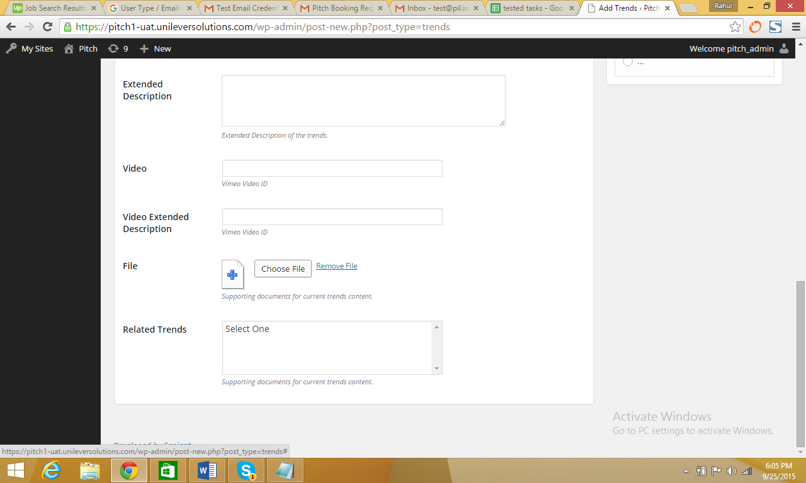

1. On successful upload the following screen will be displayed

